**NEA Analysis: Python Text-Based UNO**

**Introduction**

As a student, I find myself often looking for a quick game to pass the time when taking a break from revising and usually that game ends up being UNO. Therefore, my project for my NEA is to create a fully functional 2D shedding card type game (where the player’s main objective is to empty their hand first) that can be accessed as an executable file and run like an application on windows. This application would contain a single player function where the user can play against an AI and a multiplayer function with which up to 4 players can play locally (connected to the same server) or play against each other with the addition of an AI to fill empty spaces (if less than 4 players join the server). I will attempt to add a login system that allows the user to create an account, which will store total time played, total games played, a win to lose ratio and a possibly ranking system against other registered users.

**Analysis of Two Similar Card Games**

As UNO is a shedding type card game, I have found another two games that are similar to it:

**Boom-O (created in 2001):** In Boom-O each player is dealt 7 cards and 3-time bomb cards that represent ‘lives. Players are given cards that can either increase or decrease the timer. The main objective is for the player to put down one card per turn until they have no cards in their hand while trying to keep the timer total below 60 seconds. If a player can’t play the correct card, they must turn over one of their bomb cards, losing a life. Once a player clears their hand, all other players must turn over their bomb cards and the survivor wins.

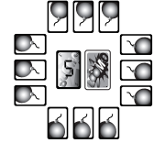

Bombs card (3 per player)

Discard pile

Draw pile

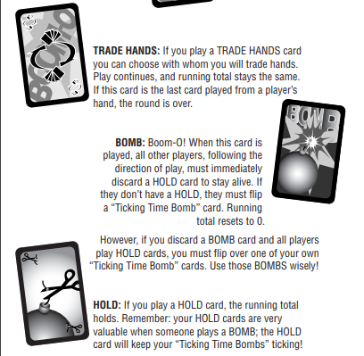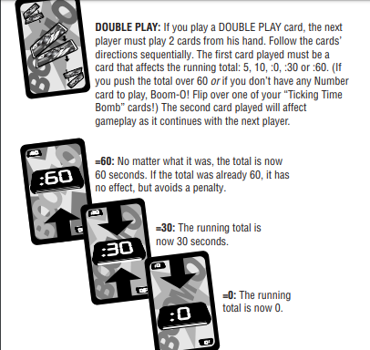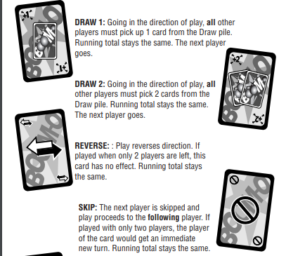

**Strengths**

* The element of a timer and ‘lives’ implemented into the card game adds a sense of intensity and urgency when playing the game, this allows the game to not last too long but be a fun game to play with friends
* The game is heavily reliant on the aspect of luck which means everyone has an equal opportunity of winning, no matter how experienced player(s) are
* Unique action cards such as ‘trade hands’ and ‘double play’ can completely change the course of gameplay in an unexpected way which makes playing the game more fun

**Weaknesses**

* The game is heavily reliant on the aspect of luck which means there’s no real strategy to learn or create.
* There is no score counter in the game which could serve as another method of winning, e.g if a player score reaches 100, they automatically win. Scores could be based on cards added to the deck.
* The rules can get quite confusing as players have to keep track of both the timer and the number of cards, they have left in their hand

**Craits(created in the 1970s):** In Craits a standard card of 52 cards is used instead of a specialised pack in UNO and Boom-O. There are 15 hands and in the first hand 8 cards are dealt per player, this amount decreases by 1 after every hand till 1 card is dealt to each player and then incremented by 1 until once again 8 cards are dealt to each player. Similar to UNO, each player takes turns in placing a card from their hand on to the pile with according matching suit or rank (this excludes an eight or nine which are wild cards). Furthermore, if a two is placed on the pile at any point ‘the count’ begins in which each player must place an Ace or a two which increments the count by 1, once a player fails to place an Ace or a two they must draw an amount of cards equal to the count e.g. if the count = 10 then the player must draw 10 cards from the deck.

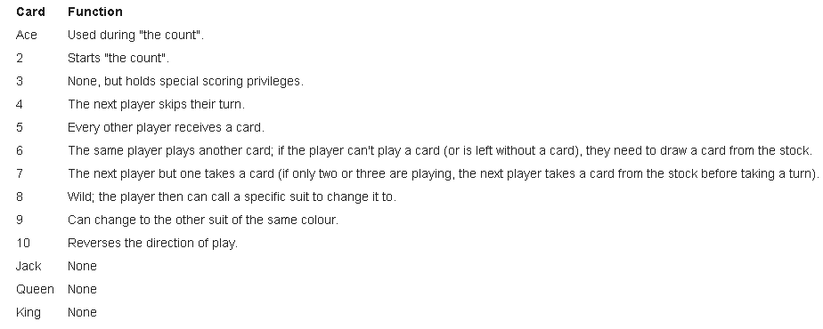

**Strengths**

* The fact that this game utilises a standard deck of 52 cards means that it is more convenient and cheaper to play as one does not need to buy a specialised deck

**Weaknesses**

* The game can get repetitive and boring quite quickly as there is no scoring system for each player
* Players may find it difficult to remember the special attributes of each card as they are just normal playing cards, this may end up confusing gameplay

**Conclusion:** Boom-O and Craits are very similar to UNO in the fundamental fact that the main objective of the game is for the player to reduce their hand to zero cards before their opponents. Boom-O is faster paced and this may appeal more to children as games do not last very long and are more intense, on the other hand Craits is a much more slow and steady game that doesn’t really have any unique aspects to it as a shedding card game but this may allow for a more mathematical, strategic approach when being played.

**Description of Existing Application**

UNO is a lot more established and well-known in comparison to other shedding type card games with many variations of the game available on Android, IOS, Xbox, PS4 and PC (windows). I will be focusing on analysing the windows version of UNO which is an application available on the mainstream digital application store, Steam. This is version which is developed by Ubisoft is the most popular online rendition of UNO to date with an estimated 500,000-1,000,000 owners of the game and the highest number of players online at once totalling up to 2,309 and up to 115,000 viewers on live streaming platforms such as Twitch.

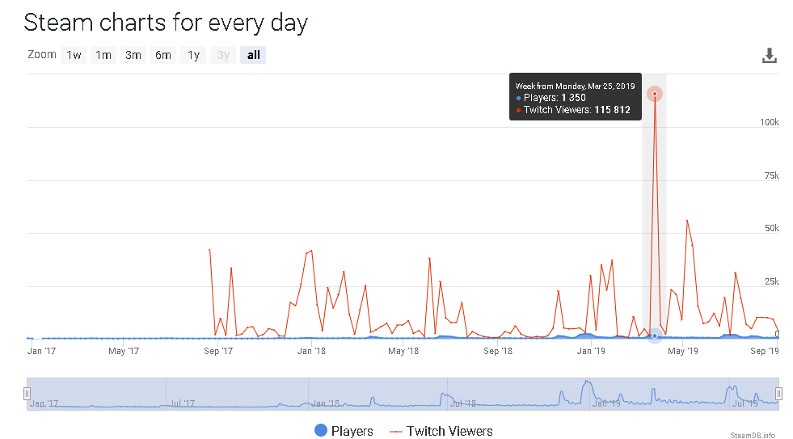

Line graph depicting the fluctuation of Players and Viewers of the game since it’s release in January 2017 till date

This version of UNO works essentially the same way as the original does, with each player given an equal number of cards from the deck and the remainder placed as a draw pile. Players must match the colour or number of a card placed down in the discard pile, or use action cards randomly distributed amongst them (including, skip, reverse, +2, +4, and wildcards) to reduce the cards in their hand to 0 first. Once a player has one card remaining, they must call ‘UNO!’ when placing their final card in their hand, if this is not done then the player must draw another card from the draw pile.

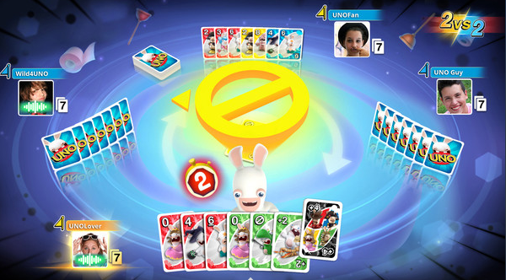

**Maths and Complexity behind UNO**

In order to create an AI for a game like UNO one must understand the maths and complexity behind it. As the AI in my game must be able to analyse playing patterns of each player and play cards accordingly to win (which includes predicted what cards a player has in their deck based on what cards have already been played).

Assuming action cards such as reverse, skip, +2, +4 and change colour are not considered. In single player mode against an AI, you and the AI are given an equal number of cards. There are 76 cards in a deck (after subtracting the action cards and 0 cards), which means each player get 38 cards. Out of the total 76 cards, there are 4 suits (red, green, yellow and blue) and each suit has 2 sets of 1-9 cards and 1 set of 0. This means there is a 2/3 chance of getting any 1-9 card of any suit and a 1/3 chance of getting a 0 card.